ManuConnect Release - 2020.12.07
Release Date | 07 Dec 2020
Core Installer | 7.0.01207.682
Installer Suite | 7.0.01207.1027

Overview
There two fixes in today's release.
CWI Nuget
The CWI Nuget package files have been updated in today's code drop.

Defects Addressed
Defect | Client No. | Category | Summary | Release Notes
MLU-856 | 10532 | Installer | [CDTASMU-10532] The Addition of Client Maintenance Member Events Causes an Issue for Client Life Events | This is an audit trail related issue. If a multi-language name or description field is a virtual field the system needs to inject additional ControlDefnId (i.e. VirtualControlDefnId) to the audit trail. This issue is now corrected.  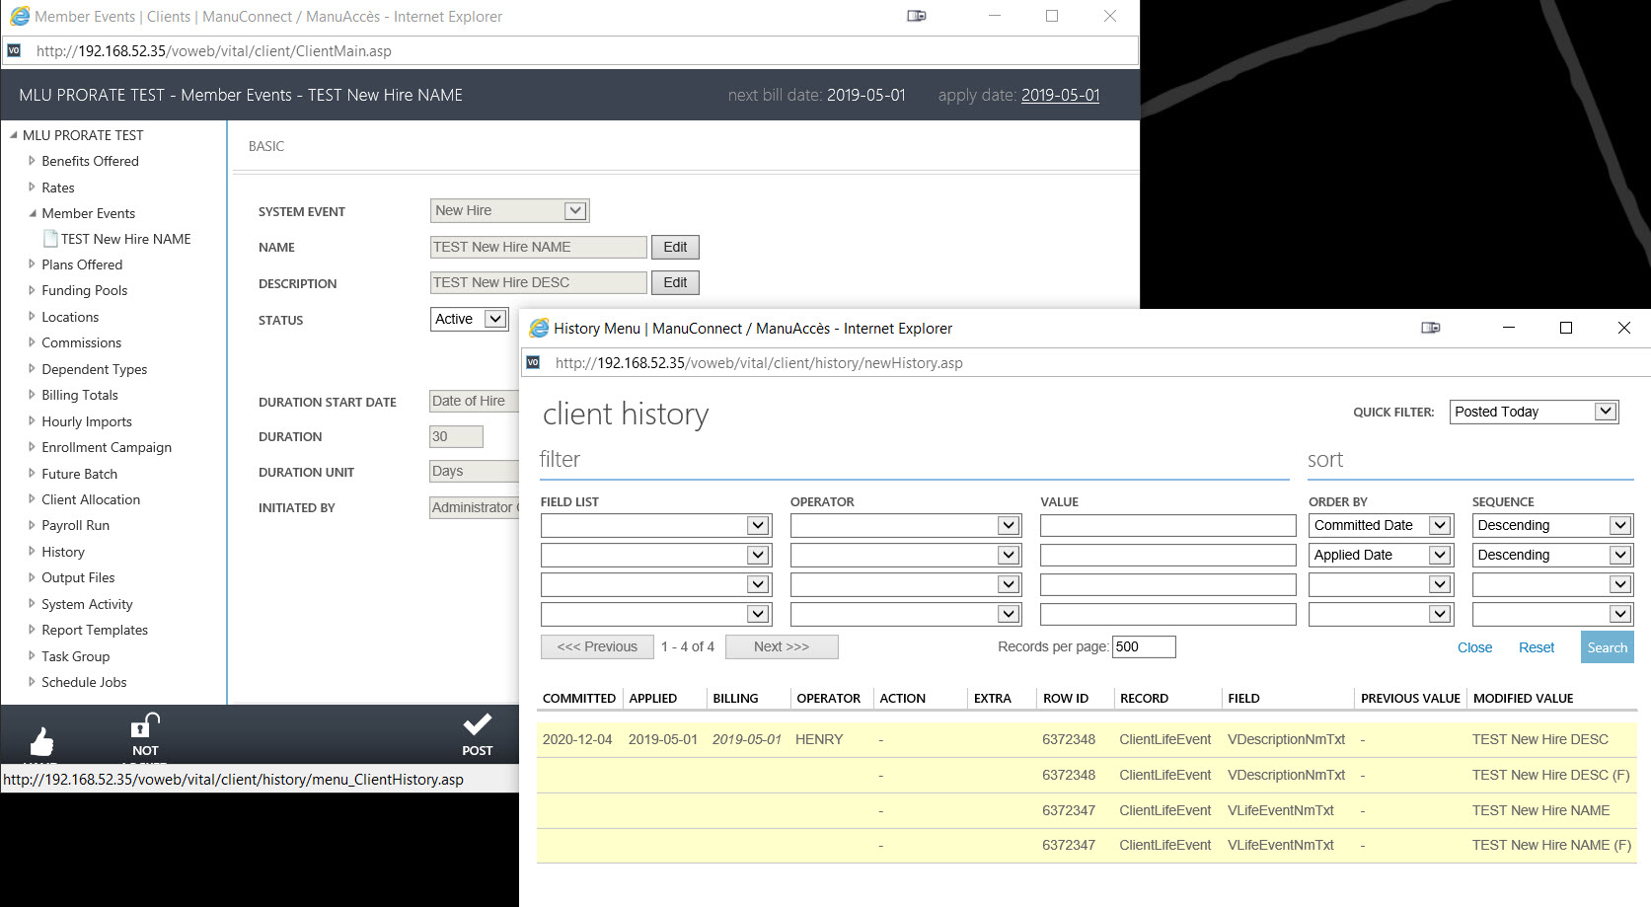  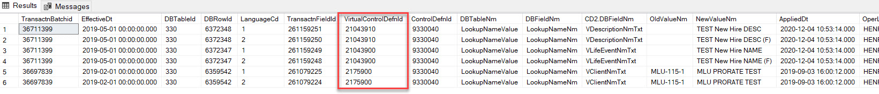  Notes:  - The audit trail flag of both the virtual field (e.g. VDescriptionNmTxt) and LookupNameValue.LookupNameNm field must be turned on.  - After any audit trail flag is changed, the VO applications (Vital Objects and Vital Objects Services) in COM+ must be shut down.  - IIS must be restarted as well
VOE-1045 |  | Admin. GUI | Client UI: New Hire NEM fields are not becoming visible after clicking on the Enable New Hire NEM | Fixed UI issue when clicking on ENABLE NEW HIRE NEM was not showing New Hire NEM fields  